**What we have done last week:**

Generated the first sample data of the grid map:

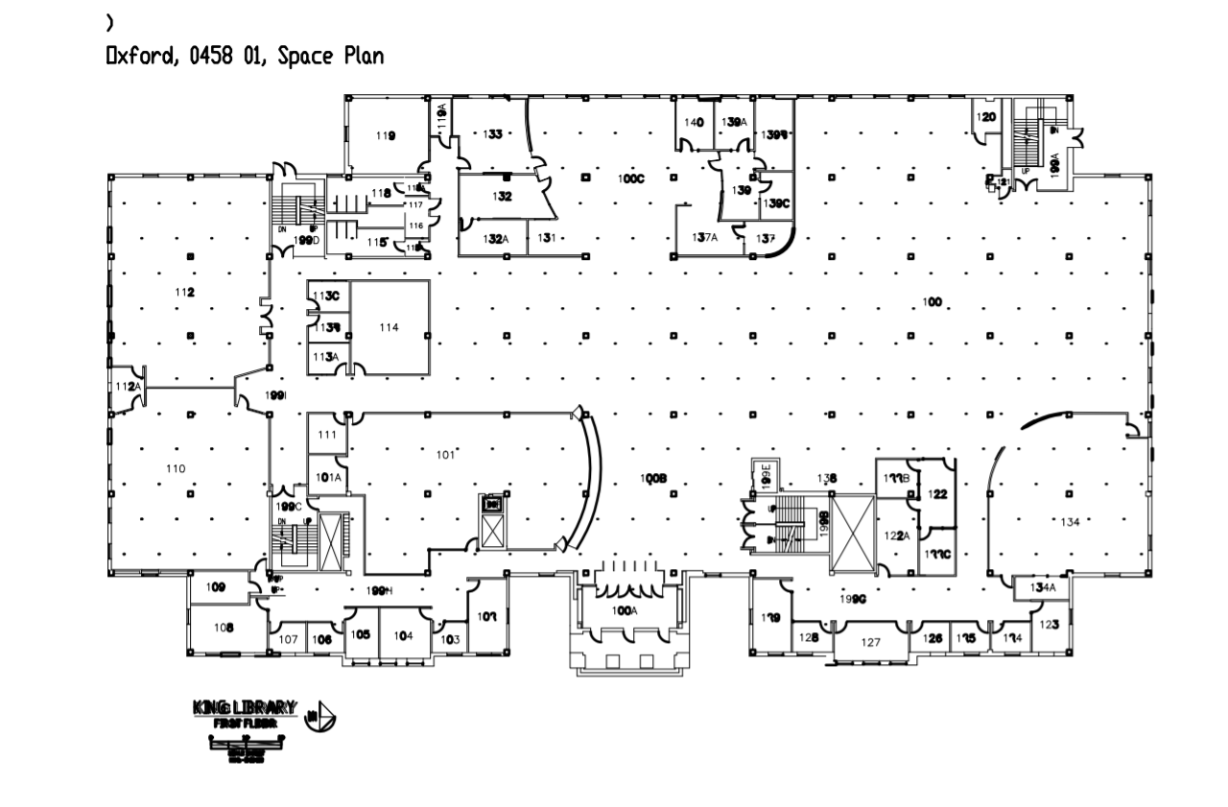

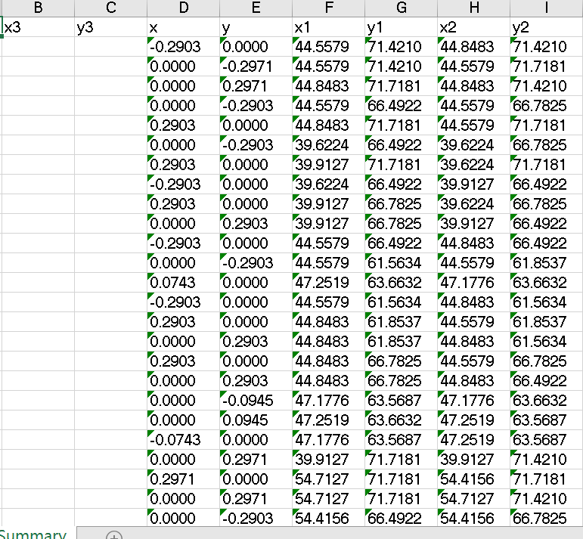

**What we are doing since the last week:**

Two group members are learning how to use two different software (Auto CAD, ArcGIS) to accomplish the transformation of the map. (ArcGIS may be more efficient to output expected data)

Writing A* algorithm based on Java, since there are many special cases in our application, it will be more complex than origin.

Building an Android app on Xamrian Form (XAML and C#):

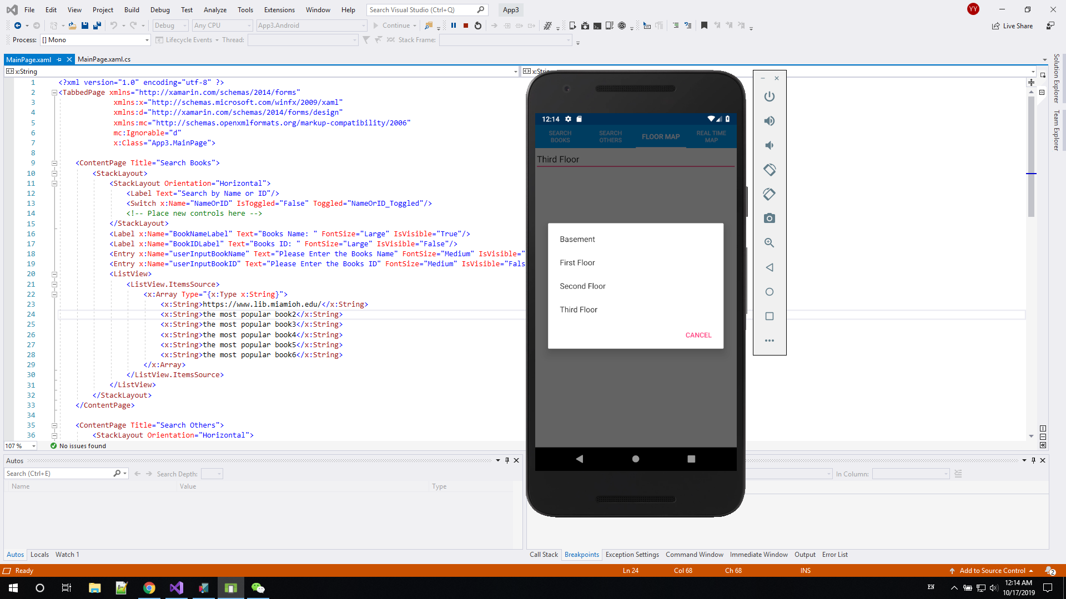

**What will be done next week:**

Initial navigating Algorithm (probably).

The first usable (processed) data for the first floor of King Library.

**Conclusion:**

Every work is in good progress and each team member has their own task to make an effort.

**Note:**

For ap data: apMaxAddress, floorId … and som many other data in jason format. But not readable for us.

Access url: <http://csebu.csi.miamioh.edu/cmx/v1/FFEERE/location/user/campbest/>